MathWorks Live Brief

Fault Detection Software Development

Introduction
You work for a startup company developing software tools that utilize Artificial Intelligence. Your team focuses on tools for classifying audio. Recently, you’ve been exploring the idea of detecting faults in industrial equipment using only audio recordings. This is a potentially lucrative concept, as industrial equipment is expensive to fix and monitor. This method is cost-effective and could detect issues before the equipment fails.
You are in the early stages of development. First, you must test your idea by training a machine learning model to classify audio data of known faults. You have access to an audio dataset containing recordings of an air compressor with seven different faults and no faults (healthy). Use this data to train and test a machine learning model.
Once you have a proof of concept, it’s time to develop a user front end in the form of a MATLAB app. Divide your team by responsibility and begin to sketch out a wireframe of your app, deciding on features and user workflow.
Finally, you will pitch your app to company managers, aiming to convince them that the idea is plausible and that your team can make it a reality.
The paper behind this idea: https://ieeexplore.ieee.org/document/7177138

Part 1 - Train and Test a Machine Learning Model

- Complete the MATLAB Onramp and Machine Learning Onramp
- Download required files (.mlx files and audio recordings) and make sure they are on the MATLAB path
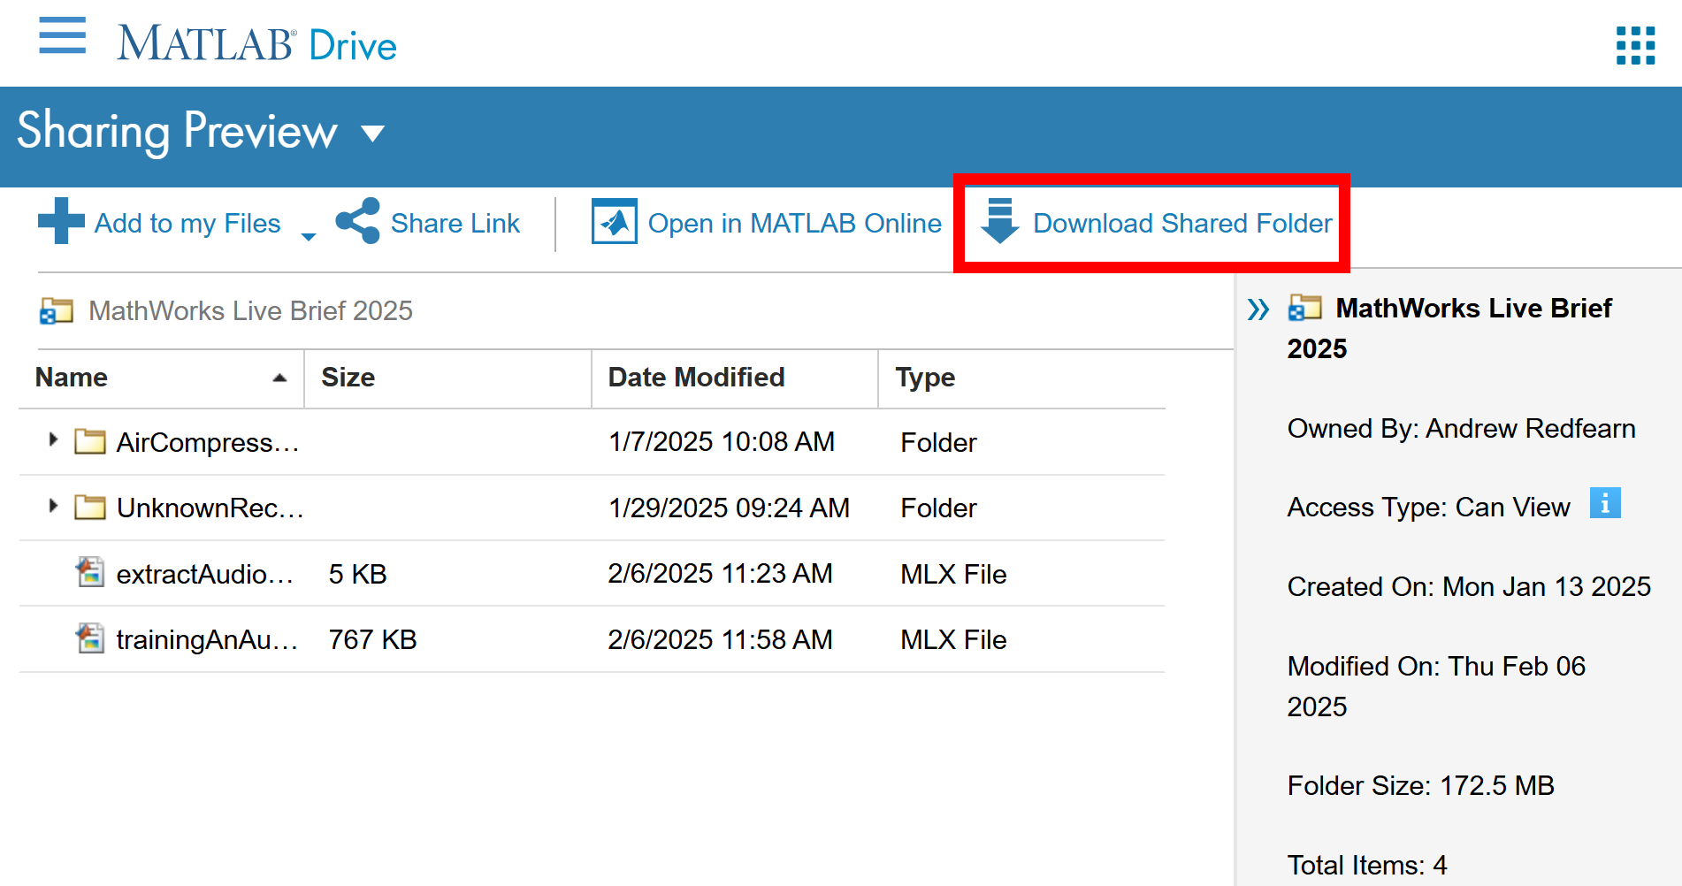
- Work through trainingAnAudioClassifier.mlx which will take you through the process of training a machine learning model for audio classification.
Within this script you must:
  - Add two more features to the feature extraction function
  - Use the classification learner app to train a machine learning model using your features table
    - Reserve 10% of the dataset for testing
    - Train three models, a tree model, SVN model and another of your choice
    - Produce a confusion matrix for each model using the reserved test data
    - Export your model
- Write a standalone MATLAB function to classify a single audio recording. This function must:
  - Import a recording into MATLAB
  - Extract the required features from this recording
  - Pass the features to your previously trained model
  - Return the fault classification

Part 2 - Design and Build a Prototype App

- Complete the MATLAB App Designer Onramp
- Divide your team into three groups based on responsibility:
  - Code Development (DEV) – Responsible for the backend MATLAB code
  - User Experience Design (UX) – Responsible for the front-end app design and workflow
  - Quality Control (QC) - Responsible for testing the app and reporting issues to the team
- Produce a wireframe sketch of your app
  - Show the general layout of controls like buttons and graphs
  - Explain how someone would use the app from start to finish
- In addition to classifying audio data from a file add a second feature to the app to make it unique.
- Work together to build the app – it doesn’t have to be fully functional, but it should be in a state where it can be presented as a prototype and there should be some evidence of testing
Suggested division of work:
DEV & UX – Design and build app front end
DEV & QC – Build and test backend code
UX & QC – Test app user experience and workflow

Deliverables

- App Pitch Presentation
  - Introduce your team and responsibilities
  - Describe a few technical details on how the technology works:
    - What features did you chose for the training and why
    - How does the model perform when tested – confusion matrix
  - Introduce your app – describe key features and the workflow with screenshots
  - Who is the intended customer who will use the app
  - Outline your progress so far
    - What is the state of the app – what has been fully tested, what is yet to be implemented
    - Outline the remaining project timeline to completion and launch
- App Demonstration
  - Talk through the design decisions you made and why
  - Demonstrate any functional features – we expect at least one functional feature

